Handley Page HPR.7 Herald 214 Series – c/n 185 – G-ASVO

2 Jul 1964 – First flight – Built - Engine x 2 Turbo-prop, Rolls-Royce Dart 532-9

23 Oct 1964 to Mar 1973 SADIA as PP-SDG

The Sadia Handley Page HPR.7 Dart Herald 214 PP-SDG (c/n 185) is the most modern aircraft present in this view of the apron at Santos Dumont Airport circa 1966. The Herald was delivered new to Sadia on 23 October 1964, and shortly after the airline changed its name to Trans Brasil on 16 Jun 1972, the aircraft returned to the UK in March 1973 for service with British Midland Airways as G-ASVO.

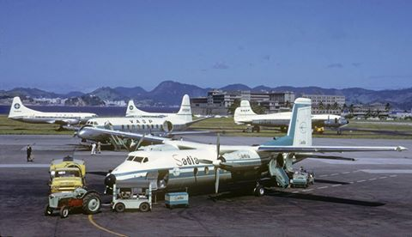

23 Mar 1973 to Jan 1977 British Midland Airways (BMA) as G-ASVO

14 Jan 1977 to 02 Mar 1993 British Air Ferries (BAF) G-ASVO

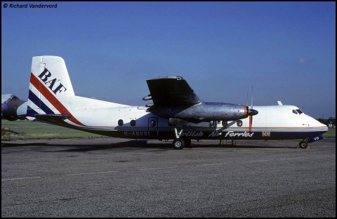
BAF’s longest serving Herald by a considerable margin of two years was Victor Oscar – a 200 series Herald that had come to the airline via British Midland Airways. She had been a regular visitor to Southend prior to her acquisition, especially being as the smaller Heralds were more increasingly replacing British Midland’s Viscounts on the Channel Island routes that had been so popular during the early 1970s. She arrived at Southend on 14 January 1977 and like many of her BAF stable mates, went on to develop a long and extensive history of leases which saw her serving with airlines in the UK, Middle East and Africa.
Four months after her purchase, she went to Gulf Air on 1 Apr 1977, Brymon Airways 4 Aug 1977 and then on to Europe Aero Services before returning to Southend late in 1978. The following January, she would be leased to British Island Airways (BIA) on their Channel Island routes to destinations such as Amsterdam, before going to Air UK for a short stint on Jan 1980. Needless to say, between these leases, she would be seen on a number of European routes flying for BAF, being seen at Brussels, Basle and Dusseldorf during the late 1970s. However, on 30 Oct 1980 she would again depart on lease, this time to Nile Valley Aviation replacing BAF Herald G-APWA on their internal Cairo taxi service route. She would remain in Africa until late 1982, serving with Libyan Arab Airlines from Jun1981 and AGIP Libya Inc from May 1982 before eventually returning to Southend. From 1983 onwards, she would remain with BAF although she was leased out to sister company, Guernsey Airlines for the 1983 summer season.
Due to a large number of Viscounts having been purchased by BAF during the early 1980s, the number of Heralds had been halved from a total of 14 aircraft in 1978 to just 7 at the beginning of 1984. However, G-ASVO and her sister Herald G-BAVX would continue to soldier on with charter and freight flights well into the 1990s, outliving a good number of the Viscounts that had initially been acquired to replace them. From the mid1980s onwards, Victor Oscar became a common site at many of the London airports and Manchester, flying passengers to among others, Jersey, Basle and Dusseldorf, while as the decade moved on, she would more increasingly find herself hauling post and freight around much of Western Europe.

Nov 1993 to Aug 1997 Dart Group PLC
Dart Group PLC leased her to a company that had already purchased or procured a good number of former BAF Heralds, namely Channel Express who had been running them into Southend nightly on UPS services until they were finally replaced with Electras in the early 1990s.
Needless to say, Victor Oscar would give her lessor almost 3-1/2 years of sterling service until she was inadvertently taxied into a lighting post at Bournemouth on 8 April 1997. The damage was considered too expensive to repair and as a result she was broken up, although the cockpit was retained for preservation.

08 Apr 1997 w/o Bournemouth

Sep 2001? Forward fuselage preserved at Highland Air Museum. (On loan from Peter Westley)

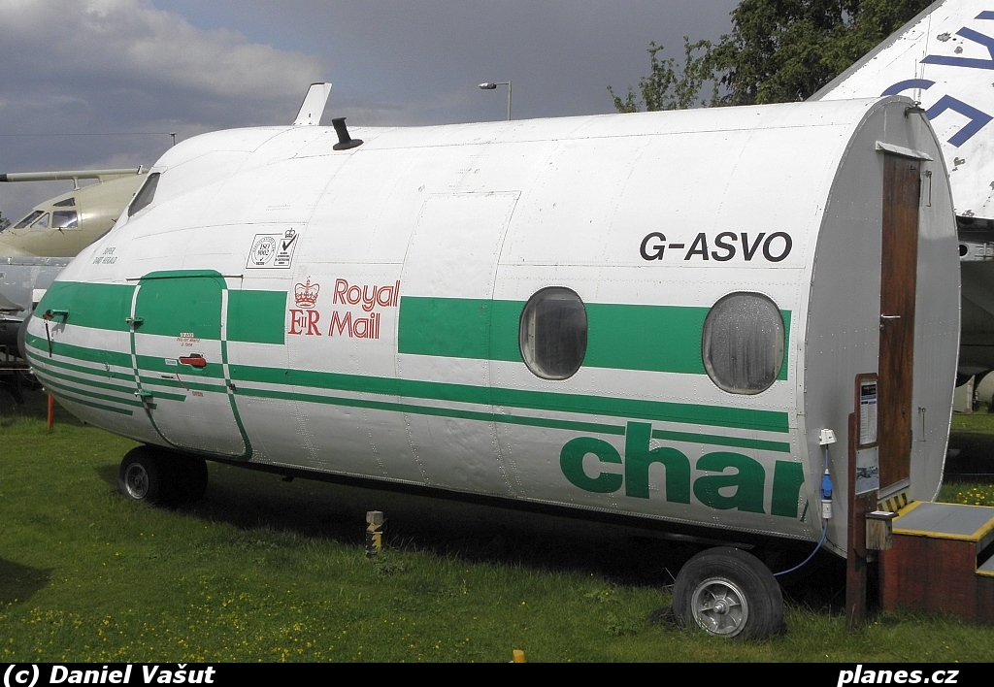

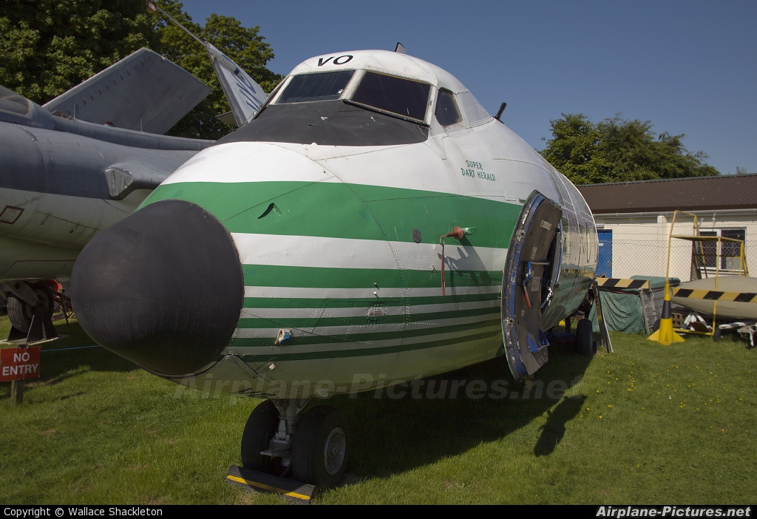

Mar 2017 to Morayvia (On loan from Peter Westley)

