SEPECAT JAGUAR GR3A XZ113 HISTORY
BAC Warton Construction No S.114
02/04/76 First flight
27/04/76 Delivered to RAF as a Jaguar GR1
13/09/80 Noted at Abingdon Airshow in 41 Sqn (A) livery
10/83 Noted in 41 Sqn (A) livery
00/84-08/87 Operated by 2 Sqn (30) Laarbruch in Green/Grey livery as a GR1
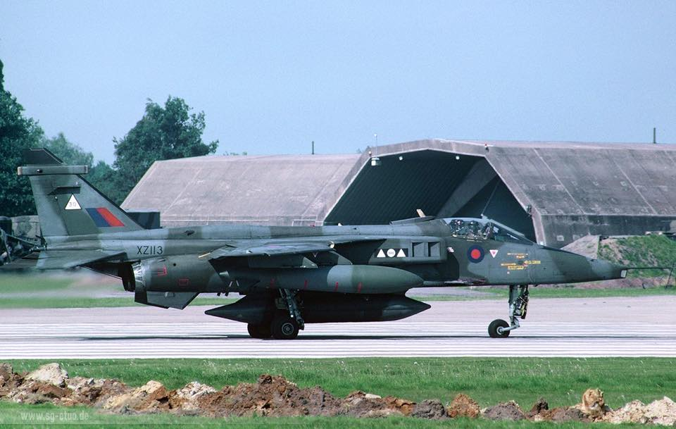
06/84 Noted in 2 Sqn (30) livery at Tactical Air Meet at Gilze-Rijen
07/90 Operated by 41 Sqn (D) Coltishall in Green/Grey livery as a GR1A
Some 25 Jaguars were converted to Granby 3 standards, with enhanced defensive aids and ECM, Have Quick radios, over wing Sidewinders, etc including XZ113
07/91-04/93 Operated by 41 Sqn (FD) Coltishall in Gulf War “Desert Pink” livery although XZ113 did not deploy to the Gulf
07/93 Operated by 41 Sqn (FD) Coltishall, 12 aircraft were despatched to Gioia del Colle in Italy as part of a NATO force made available to support UN operations in the former Yugoslavia, including XZ113
17 Jaguars were converted to J96 Recce, including XZ113
Some Jaguar 97s were produced through the conversion of existing Jaguar 96s, including XZ113
06/97-10/98 Operated by 41 Sqn (FD) Coltishall in Grey livery as a GR3
23-25/07/99 Noted at the RIAT Fairford in 41 Sqn (FD) livery
08/03 Operated by 41 Sqn (FD) Coltishall in Grey livery
01/04-04/04 Operated by SAOEU at Boscombe Down in Grey livery. Unit moved to Coningsby and changed name
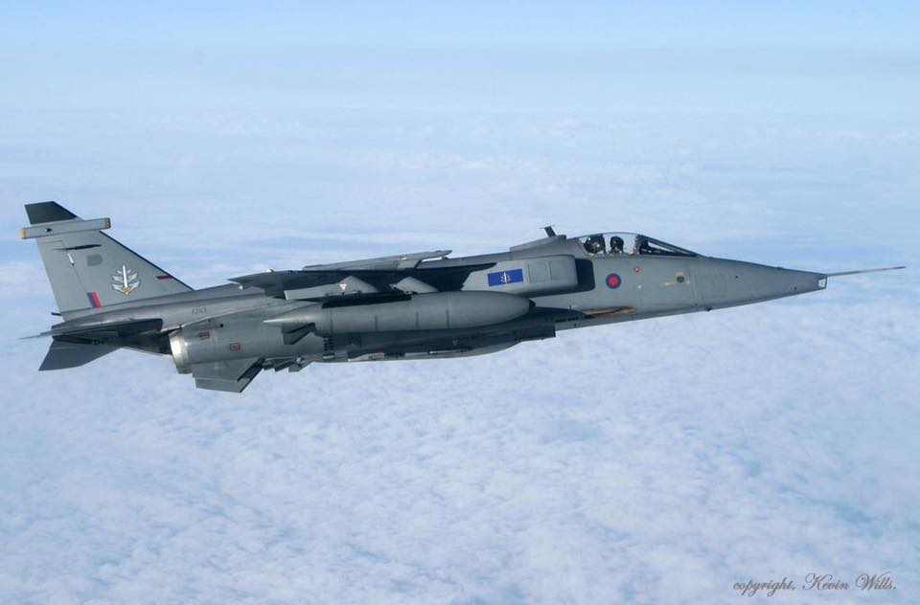
04/04-11/05 Operated by FJ&WOEU at Coningsby in Grey livery
00/12/05 Retired from RAF
15/03/06 Delivered to DARA St Athan for spares recovery
00/08/06 Delivered to Everett Aero, Bentwaters
01/08/16 Delivered to Charles Phillips Auctions at Musselburgh
11/05/17 Delivered to Morayvia, Kinloss

