Avro Vulcan B2 MRR XH563

22/12/60 Completed as a Vulcan BMk2, the 17th aircraft of Contract 6/Air/11301/CB.6(a)
28/12/60 Delivered to 83 Sqn Scampton. Fitted with Olympus 201 engines it was the first B2 delivered to a squadron, the earlier B2s having been delivered to the OCU
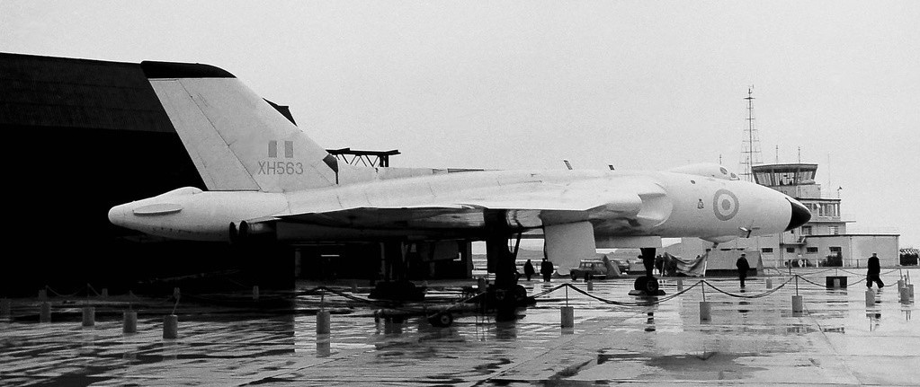
26/11/62 12 Sqn Coningsby
00/06/63 Woodford to be converted to Skybolt fit, later flew to USA for electrical trials work
05/03/65 230 OCU Finningley
06/08/68 Waddington Wing (44, 50 and 101 Sqns)
18/03/69 230 OCU Scampton, with some 5 months in 1969 spent on loan to the Ministry of Technology
03/05/71 Scampton Wing
07/05/71 230 OCU Scampton
09/02/73 Woodford for conversion to B2 MRR (Maritime Radar Reconnaissance) standard
17/12/73 27 Sqn Scampton, the first B2 MRR version on the Sqn, also underwent Air Sampling Modifications
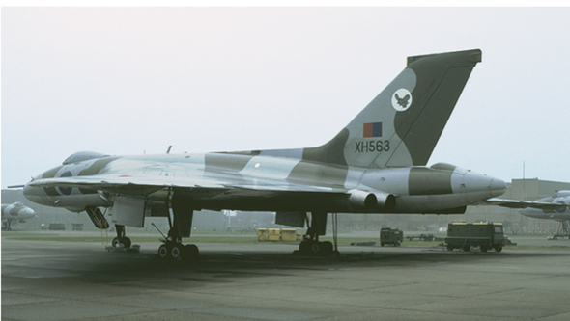
23/03/82 Last flight and withdrawn from use
31/03/82 Allocated 8744M for preservation at Scampton, temporarily used as a Gate Guardian
00/11/86 Scrapped, nose section to Bruntingthorpe
00/02/87 Purchased by Donald Milne of Banchory
21/05/03 Purchased by Paul Hartley and stored at Nev Martins yard at Bruntingthorpe
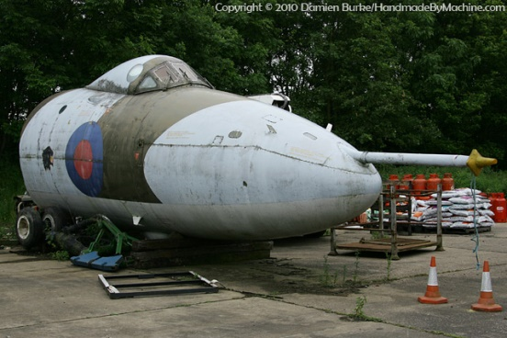
00/04/10 Purchased by Ken Ward and stored at Over Dinsdale, Yorks
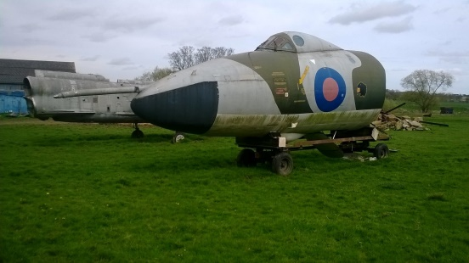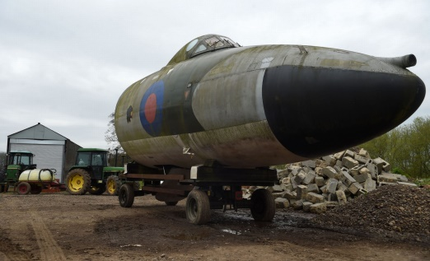
30/04/17 Loaned to Durham & Tees Valley Airport for the Skylive 2017 Airshow and then stored at the airport
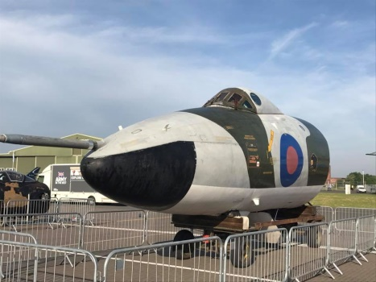
00/03/18 Loaned to Morayvia
18/12/18 Transferred from D&T Valley Airport to Morayvia
